

Azure Assignment

Bench Training



May 18, 2023

Sagar khatri

sagar.khatri@nagarro.com

Azure Assignment

Login into the Azure account

* Create a virtual network with 2 subnets. Each subnet shall have 16 internet protocols each.  
  Search virtual networks in the search bar, then create virtual networks and subnets too.
* A screenshot of a computer

  Description automatically generated

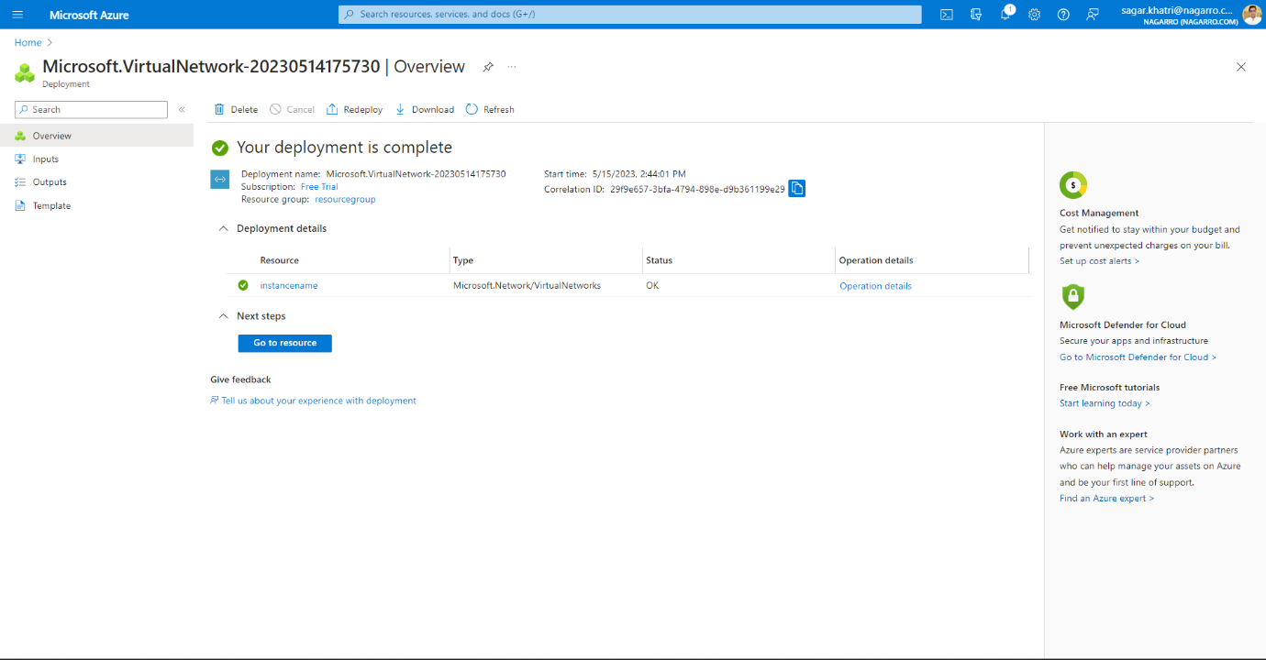

Click on review+ create after completing the review, click on the Create option. It will create Virtual network with 2 subnets.

* Inside one of the subnets, create VM and deploy an application code inside it and it should leverage the database on cloud. Search virtual machine in the search bar.
* A screenshot of a computer

  Description automatically generated with medium confidence

Fill the network tab and then click review and create.

Now click review and create button.

Now click on the create button on the bottom left corner of the screem.

Now you can see the overview of the virtual machine deploytment. Wait for sometime and let the deploymenmt complete.

For running the virtual machine on the local computer then download the rdp file after clicking on the connect button.

Wait for the rdp file to get downloaded on your pc.

Once the rdp file is downloaded. Run the rdp file using the Admin privileges on your computer.

For publishing the database on azure first create the webserver on the azure.

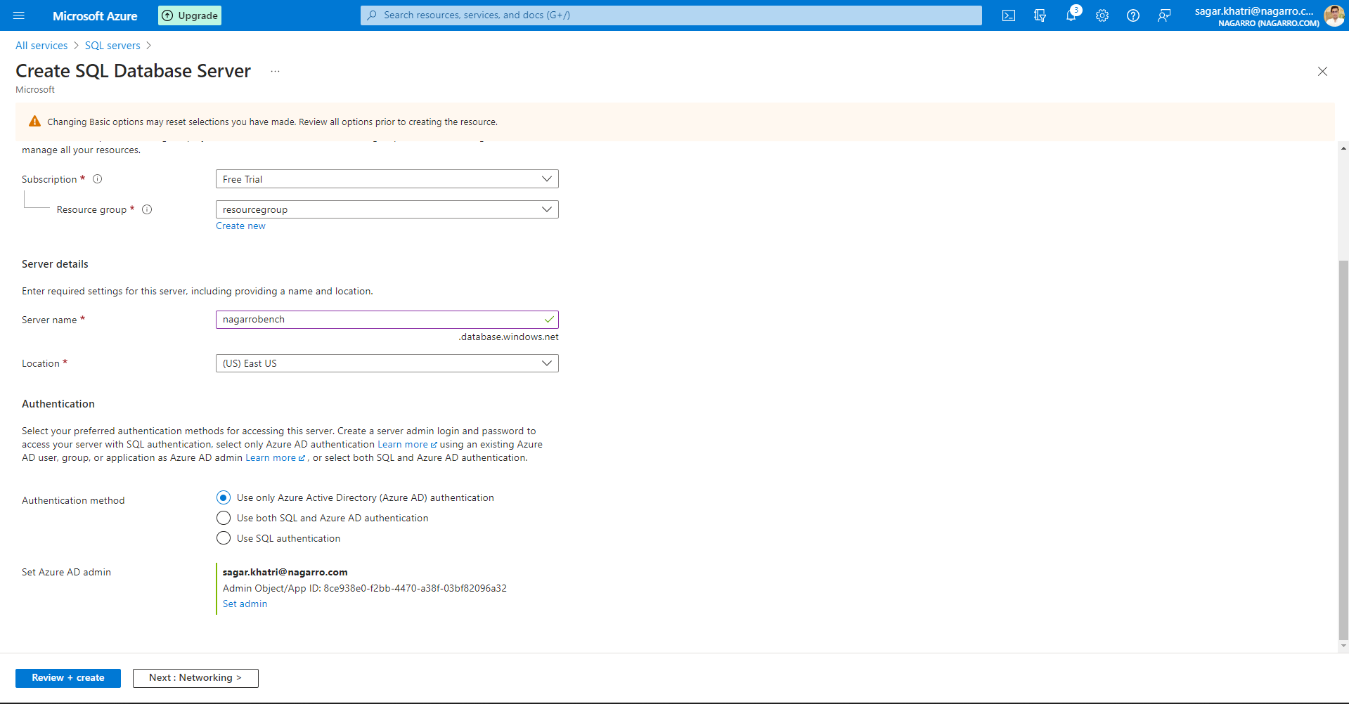

Then click on review + create.  
Now click on create and wait for the webserver to get deployed.

Once deployed, the webserver will look something like this:

Then open the Microsoft sql server management studio for publishing the database. Then right click on the database name and then click on deploy database to azure.

Then click on next and connect to azure web server by providing the credentials. After finishing opening the azure webserver then the database will the there.

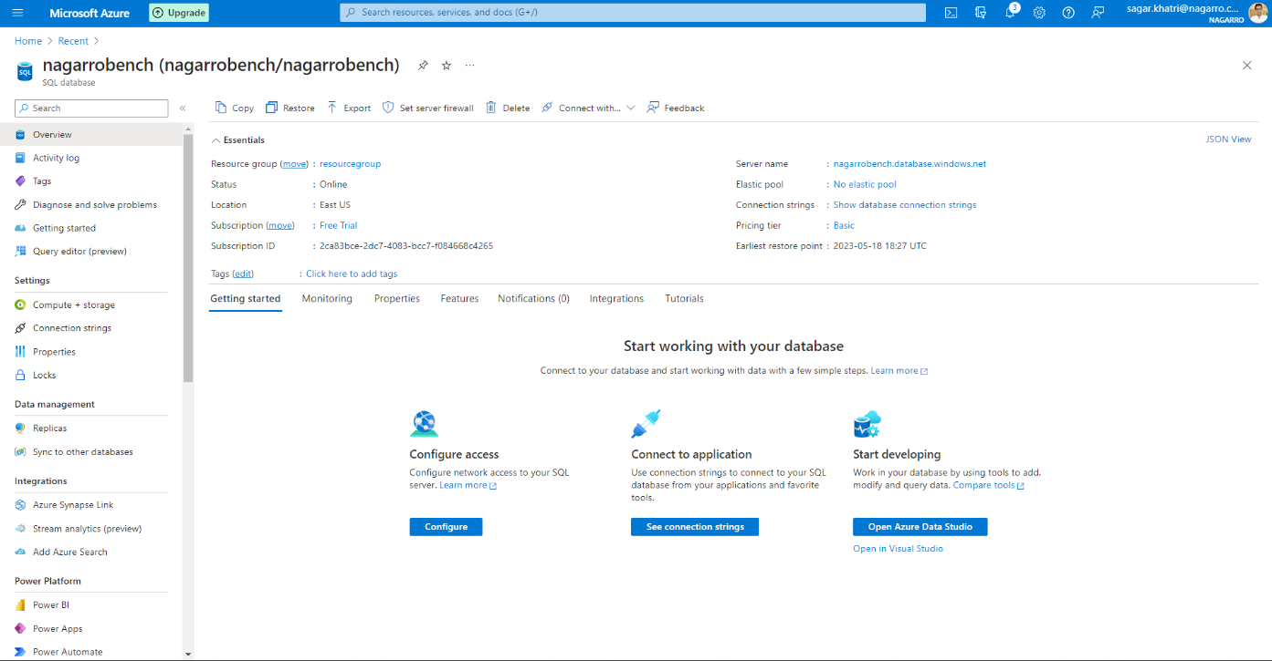

For connecting the application with azure database copy the connection string and then paste it in index.js file of the application.

Now copy the relevant information and paste it in your application

Deploy the same application to azure app service. It should also leverage the database on cloud.

Open the visual studio then right click on the project and then click on the publish button.

Then on the publish window selevct Azure App service and click next.

After clicking on the finish button, the application will be deploy using app service on azure cloud.

Click on the button review + create after filling the information carefully about your project. Then click on create button on the subsequent screen.

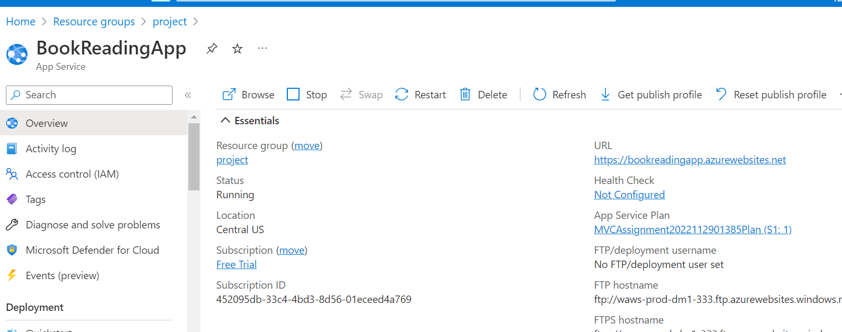

Now, lets create the AKS cluster.

Search Kubernetes cluster in the search bar.

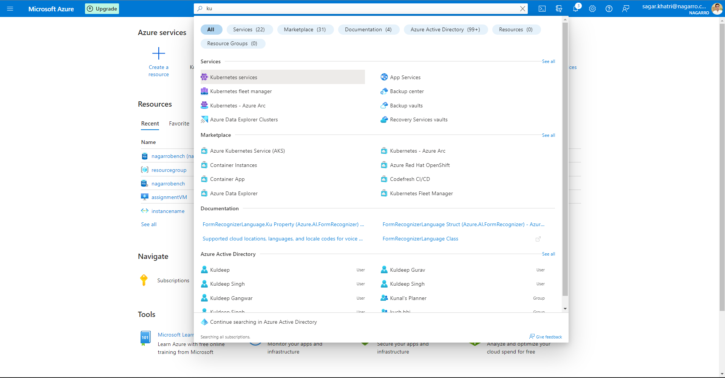

You will see a page with no Kubernetes serevices to display.

Create a new cluster by clicking on the create button.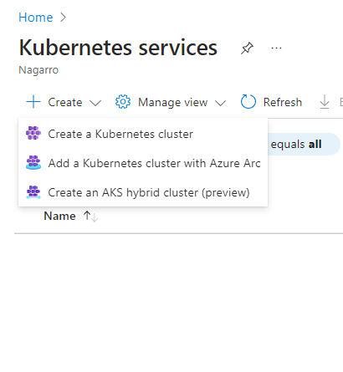

Now ‘create a new cluster’ button should be clicked and the required information should be filled.

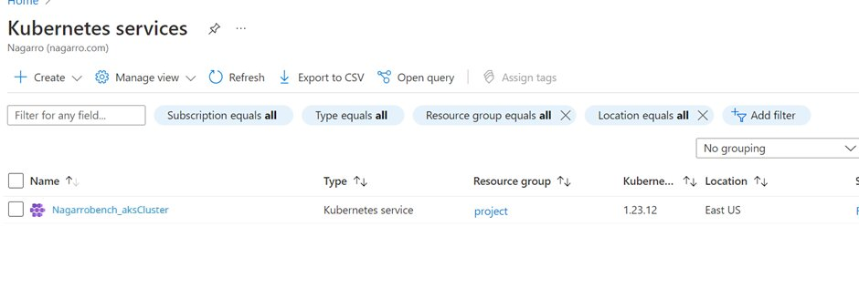

Now you can open the cluster to view the information related.

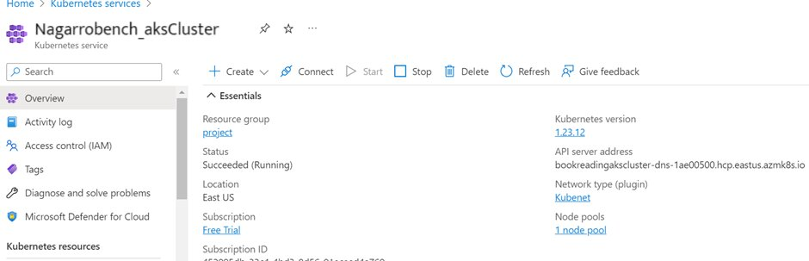

Create an azure function that should trigger as soon as you upload the file in the blob storage. Function should be able to print the name of the file uploaded in the function.

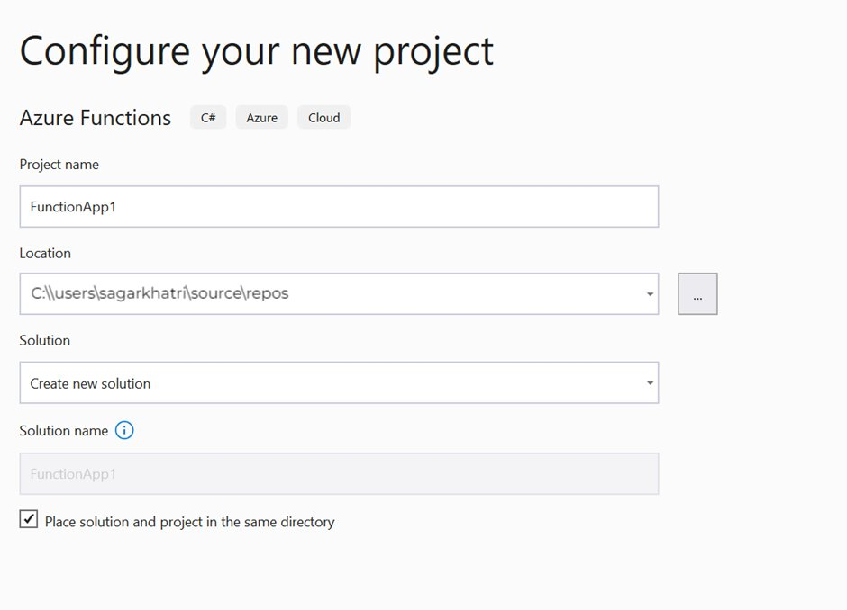

Now, Copy the connection from local.settings.json file and paste it in function argument.

Open the cloud explorer and then create the blob container in which we upload the file.

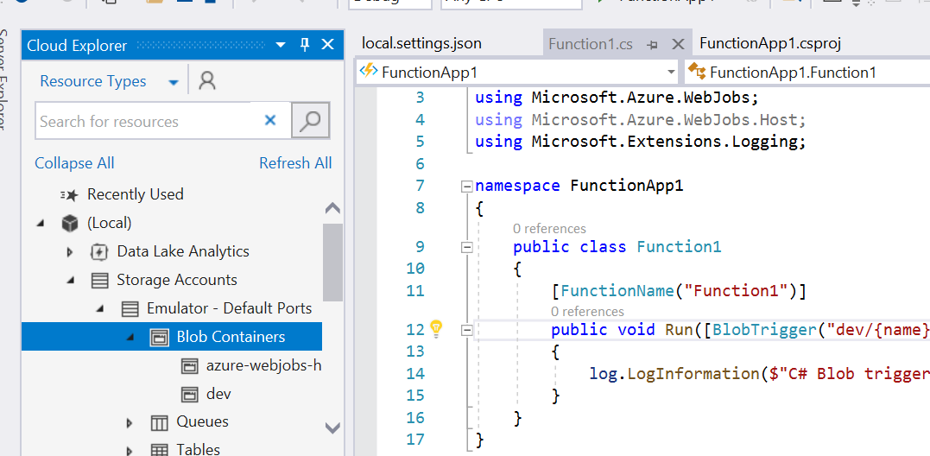

It should display the output like thius :

THANK YOU !